Music Tuition at HCH
Learning an instrument offers innumerable benefits to our students, encompassing the intellectual,
physical, social, spiritual and so much more. At HCH, we offer a variety of instruments for our students to learn with our fantastic team of visiting music teachers.
Students in year 2 and above can choose from violin, viola, cello, recorder, flute, clarinet, saxophone, trumpet, piano, drums and vocal tuition.
Our children in Reception and Year 1 are able to sign up for recorder lessons and it is an excellent instrument for small hands to ground the fundamentals of their musicianship.
There are performance opportunities throughout the year for our students to perform as soloists or
small ensembles, supported by their instrumental teacher, as well as clubs for students to come together and play with the support of a school music teacher.
If you are interested in discussing musical opportunities, please contact Rosalind, rri@hchnet.co.uk.
For more information, and to sign up for lessons, please complete this application form.
Meet some of our Visiting Music Teachers
 | Aldevis Tibaldi, Teacher of Saxophone |  | Dominic Cotton  Teacher of Trumpet
 | Aleksandra Timarov Stanojevic Teacher of Piano |  | Kieran Brunt  Teacher of Singing, Choirmaster (Chamber Choir)
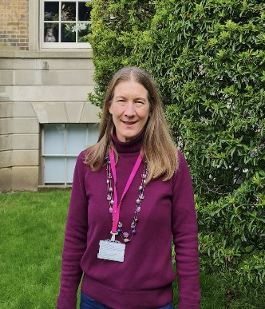 | Amanda Allen Teacher of Piano and Flute |  | Lucy Cronin  Teacher of Singing
 | Emily Bloom  Teacher of Recorder and Flute | 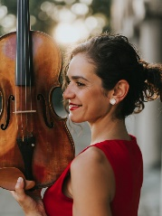 | Ralitsa Naydenova Teacher of Violin, Viola and Cello
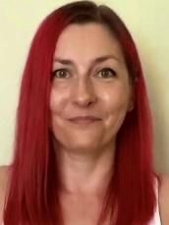 | Julie Bruce  Teacher of Drums, Percussion and Music Theory |  | Roberto Manes  Teacher of Guitar

Music Clubs
Co-curricular music is an important part of a child’s musical progression. Clubs include:
Junior Ensemble Junior Choir
Senior Ensemble Chamber Choir
The above clubs are available to book on EVOLVE.

We also have Music Theory Club on Friday lunchtimes, led by Julie Bruce. Please contact music@hchnet.co.uk to sign up.

Information for Current Instrumental Students
Fundamental Expectations
Practising between lessons is key to success. Students should have easy access to their instrument and a practice space at home.
Instrument teachers will advise how much each student needs to practice. In general, we advise the formula of ‘a little and often’: 15-30 minutes of practice each and every day is a good starting point!
Scheduling
Lessons generally take place on a weekly basis, usually with 10 lessons per term (payable to the teacher in advance), and can be 30 or 45 minutes long. Lesson times are rotated each week, meaning the student will have a different lesson time, to minimise the impact on their academic lessons. This system works very successfully and allows students to reap the benefits from both academic and musical pursuits.
Music lesson times will be emailed out by the instrumental teacher by the Thursday of the week before the lesson. Lesson times are also available to see on the Music Notice Board, outside LG14.
It is imperative that students (and Prep parents) take responsibility for the lesson times. If there is a problem with the time, you must let the relevant instrument teacher know with at least 48 hours’ notice so they can support a swap. Without this notice, lessons are chargeable, even if the student does not attend the lesson. It is not the role of the peripatetic to ‘make up’ the time elsewhere in the day. We do all we can to avoid clashes we know about in advance.
Occasionally, peripatetic teachers are unable to make their allotted day at school and so either cancel the lesson and provide a refund, or come to school on a different day. If they come to school on a different day this will be shown on the timetable, and notice will be given by the teacher in the preceding week.
Students in reception to Year Four will be collected from their classes by their instrument teacher. Students in Year Five and above are expected to attend the lessons independently.
For Julie’s drum/ percussion students: please note that Julie’s lessons will begin in the week of 30 September at the earliest. She will be in touch with you in advance of the first lesson.

More information is available on the application form: https://forms.office.com/e/wVdpwGMmJN

